
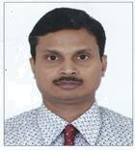
Dinesh Pratap Singh, PMP

Mobile: +91 – 7204080001

Tel. (Res.): +91 – 80 – 65900419

E-Mail: dineshpsingh@yahoo.com

JOB OBJECTIVE

Seeking managerial assignments in Software Development / Software Testing / Project Management with an organization of repute in Bangalore

PROFILE SUMMARY

- A dynamic professional with over 19 years of rich experience in Project Management, Agile Methodologies, Software Testing and Software Development; holding rich onsite experience of over 2 years in USA

- Verifiable experience in Project Management Life Cycle, based on Agile & Waterfall Models, including planning, designing & executing project framework, project planning, execution, controlling, time management, schedule development, resource management, project progress monitoring and delivery

- Adept in serving as Single Point of Responsibility for Software Development Life Cycle with complete accountability of Requirements Gathering, Programming/Coding, Application Development, Production Support, Testing and Maintenance at client’s site

- Expertise in testing software entailing inception, requirement specifications, planning, designing, configuration, release management, defect prevention, root cause analysis & documentation to stage of roll out and post production support

- Specialization in handling Functional Testing, Regression Testing, System Testing and Automation Testing

- Proficient in working on various automated test tools such as QTP and Selenium

- Having experience in IT Service Management

- An enterprising team leader with effective communication, problem solving, troubleshooting, people management, mentoring and coaching skills
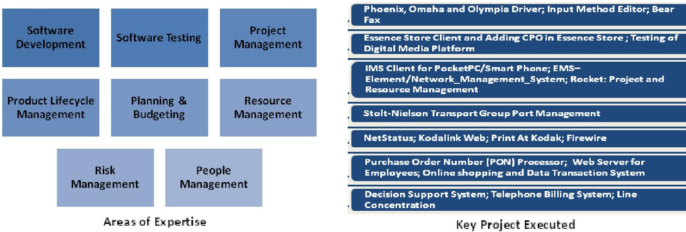

TECHNICAL EXPERTISE

Well versed in:

- GIT, SVN, windows, scrum, linux, embedded linux, Embedded Software /firmware, javascript, vbscript, automation, System Testing, QTP, Selenium, ALM, Qality and SDLC Models, C, C++, VC++, C#, python, Java, j2ee, Web Services, SOA, Spring, Hibernate,SQL / PL SQL, REST, Design Patterns.

ORGANISATIONAL EXPERIENCE

May’05 - Feb '14 worked with HP HSSL, Bangalore as System Engineer

Apr’03 – May’05 worked with Satyam Computer Services Ltd., Bangalore as System Analyst

Aug’02 – Mar’03 with Infinite Computer Solutions, Bangalore as Sr. Software Engineer

Key Deliverables:

Project Management

- Managing overall execution of projects involving scoping, risk management, design & architecture, resource mobilization and execution; monitoring / tracking projects with respect to budgeted cost, demand forecasts and time over-runs in order to ensure timely execution of projects

- Addressing all important issues and defining best practices for project support & documentation; conducting project closure meetings and addressing all important issues

Software Development:
- Interfacing with clients for gathering business requirements, conducting system analysis and finalizing technical / functional specifications; developing high level design documents for the project

- Contributing to the design, development, testing, troubleshooting and debugging of the software; ensuring smooth implementation and testing at client location; providing post-implementation, application maintenance and enhancement support to the client

Software Testing:

- Preparing testing strategy / plans / scenarios / cases and managing actual implementation of the test cases; defining, establishing, implementing, maintaining and monitoring group - wide testing methods, QA processes and quality metrics within the parent organizational framework

- Ensuring the bug defect density is minimal & automating business scenarios and functional test cases to the maximum; ensuring change request and enhancement are effectively implemented with necessary regression testing

Highlights:

- Played a stellar role in saving 12% effort in System Testing of Phoenix Printer by restructuring system test cases and eliminating duplicate test cases in 2012

- Steered complete automation of System test cases for photo printers by using XP-VAPI VB Script and T-Plan Robot for OMAHA and Phoenix printers; this was also used to automate system test cases of all printers accessed by VNC or RDP

- Instrumental in leading Test Team of 10-15 members

Awards & Appreciations Received:

- Certificate of Recognition from Eastman Kodak, Beltsville, MD, USA on 8th Dec 2000for making Washington Development Center as “Best In-
Class” CMM Level 2 Organization
- Certificate of Participation as a Competitor in Flashpoint 2006 IPG Business Plan Competition

- Received Appreciation Award from Satyam Computer Services Ltd., Bangalore, India for making a key contribution in completion of ROCKET Project

- Won Mini Improvement Award for automation of UI Testing of firmware of OMAHA Photo Printer

Refer to Annexure for Projects Executed

PREVIOUS EXPERIENCE

Mar’00 – Jun’02 with Infobhan Softworld, Santa Clara, CA, USA as Software Engineer

Jan’98 – Feb’00 with C-DAC, Pune as Software Engineer

Jun’94 – Jun’97 worked with Telenet System Pvt. Ltd., Mumbai as R&D Engineer

CERTIFICATION

• Certified Project Management Professional from PMI (PMP#315749 Jan 2006 – Jan 2016)

EDUCATION

Master of Science (Computer Science) from J.K. Institute, University of Allahabad, Allahabad, U.P. in 1993

Bachelor of Science (Physics, Mathematics and Statistics) from University of Allahabad, Allahabad, U.P in 1991

Diploma in Advanced Computing from ACTS C-DAC, Pune during Jul 1997 to Jan 1998

TRAININGS ATTENDED

Vocational Training at Indian Telephone Industries Limited, Naini Unit, Allahabad during 28th June to 15th July |  |  | 1993; executed a
project on “Virus Detection and Removal”
PERSONAL DETAILS
Date of Birth |  | : 16th December 1971
Address |  | : No. 12, 10 Cross, Akshaya Nagar, 2nd Block, Rammurthy Nagar, Bangalore - 560016
Passport Details |  | : No. F4356267; Valid Till: 08/07/2015
Languages Known |  | : English and Hindi
ANNEXURE
PROJECT EXECUTED
Title | : Phoenix, Omaha and Olympia Driver
Period | : Since Nov’08 - present
Team Size | : 5
Tools | : Application Life Management, Continuous Integration Tool (Hudson), HP Code Review (HPCR) Tool
Role | : Test Leader

Scope: Phoenix is Photo Printer based on Edge Line Inkjet Printer. It takes input of 7 media sizes and produces 17 different photo products including photos, greeting cards, photo album, calendars and collage. Omaha Printer is a Minilab Printer and supports 2 sizes: 4x6 and 5x7. Omaha takes input as precut sheet of 4x6 and 5x7 and produces output of 4x6 and 5x7. There is a Touch Screen Kiosk (having Photo Center software installed) and by using a user can send print job to phoenix and Omaha. Olympia is a Photo Printer which takes input roll feed of Photo Media and produces a variety of photo products. Windows Driver enables users to send print job to Olympia using 3rd party tools like Adobe Photoshop, Light Room, Illustrator, Microsoft Paint, etc.

Responsibilities :
- Driving the attainment of set deliverables of Phoenix, Omaha and Olympia Driver within deadline by leading a Test Team of 15 members

- Coordinating the work of various teams such as Developers, Testers and Qualification

Attainment: Attained significant reduction in cost of project through automation of testing

Title : Input Method Editor
Period : Apr’08 - Nov’08
Role : Project Leader
Team Size : 5
Tools : Microsoft Visual Studio, Clear Case, Win XP

Scope: The project aimed at development of Firmware Software in Windows XP for Input Method Editor for Asian Language

Responsibilities :

- Led a team of 6 members

- Successfully coordinated the work of various teams such as Developers, Testers and Qualification

Attainment: Attained significant reduction in cost of project through automation of testing

Title : Bear Fax
Period : Nov’07 - Mar’08
Role : Project Leader

Team Size : 8
Tools : Microsoft Visual Studio 2008 (beta 2), SVN, Win XP

Scope: The project involved development of Firmware Software in Windows XP and Windows CE environments. It had FAX, PDL, Print Device, Print Engine and Phoenix sub-systems. Fax Project aimed at sending and receiving Fax by Printer in windows XP environment as well as Windows CE environment.

Responsibilities :

- Led a team of 10 members

- Drove continuous improvement and worked on metrics for Lean Sigma

- Steered continuous improvement for Bear Fax and PDL, Print Engine, Print Device and Phoenix projects

Title : Essence Store Client and Adding CPO in Essence Store
Client : hp
Period : Apr’07- Oct’07

Role : Project Leader
Team Size : 8
Tools : Java, Web Services, JavaScript, SVN, Win XP

Scope: hp Lab had developed Digital Media Platform (DMP). DMP had 3 modules: Repository, Content Processing Operations and Scheduler. Digital Content was stored in Repository. In turn, Storage Area Network (e.g. ADIC) was used to store it. Essence Store was a special version of Repository catering requirements of Assent Media Group related to policies of ADIC for storing essence. Using Essence Store, one could import essence into it and export essence from it to external location. DES HSSL Team delivered client of Essence Store. The client updated Meta data. New feature, Role based access of Essence Store to Essence Store users, was planned to add in Essence Store. Transcoding was done by using open source codecs. Also features like adding subtitles to video, water marking and parallel transcode were planned to be added.

Responsibilities:
- Developed Work Breakdown Structure of tasks, created plan and managed risk

- Provided domain knowledge to the team regarding Transcoding; arranged talks with the Team

- Ensure effective utilization of the resources within different stream of work

- Reported about progress of project to Manager

Other Projects

- Testing of Digital Media Platform; Client: HP Des Corvallice, USA; Period: Aug’05-Dec’06; Role: Project Leader

- IMS Client for PocketPC/Smart Phone; Client: hp; Period: May’05-Aug’05; Role: Project Leader

- EMS–Element/Network_Management_System; Client: Satyam, Bangalore; Period: Aug’04-Mar’05; Role: Project Leader

- Rocket: Project and Resource Management; Client: HP IPG, Bangalore; Period: May’03-Aug’04; Role: Project Leader

- Stolt-Nielson Transport Group Port Management; Client: Infinite, Bangalore; Period: Aug’02-Mar’03; Role: Project Leader

- NetStatus; Client: Verizon, Arlington, VA, USA; Period: Nov’01-Jun’02; Role: Project Leader

- Kodalink Web; Client: Eastman Kodak, Beltsville, MD, USA; Period: Feb’01-Nov’01; Role: Project Leader

- Print At Kodak; Client: Estman Kodak, Beltsville, MD, USA ; Period: Nov’00-Feb’01; Role: Project Leader

- Firewire; Client: Eastman Kodak, Beltsville, MD, USA; Period: Jul’00-Nov’00 ; Role: Project Leader
- Purchase Order Number (PON) Processor; Client: Verizon, Arlington, VA, USA; Period: Mar’00-Jul’00; Role: Project Leader

- Web Server for Employees (Intranet); Client: C-DAC Pune, India; Period: Jan’99-Mar’00; Role: Project Leader

- Online shopping and Data Transaction System; Client: C-DAC Pune, India; Period: Aug’98-Jan’99; Role: Project Leader

- Decision Support System; Client: Western Naval Command, Mumbai, India; Period: Jan’98-Aug’98; Role: Project Leader

- Telephone Billing System; Client: Telenet System Pvt. Ltd., Mumbai, India; Period: Dec’96-Jun’97; Role: Developer

- Line Concentration; Client: Telenet System Pvt. Ltd., Mumbai, India; Period: Jun’94-Dec’96; Role: Developer

